Traditional NAT Gateway:
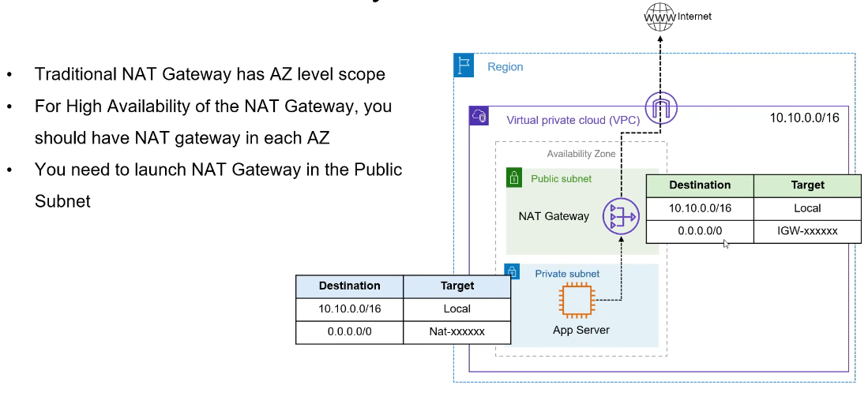

Regional NAT Gateway:
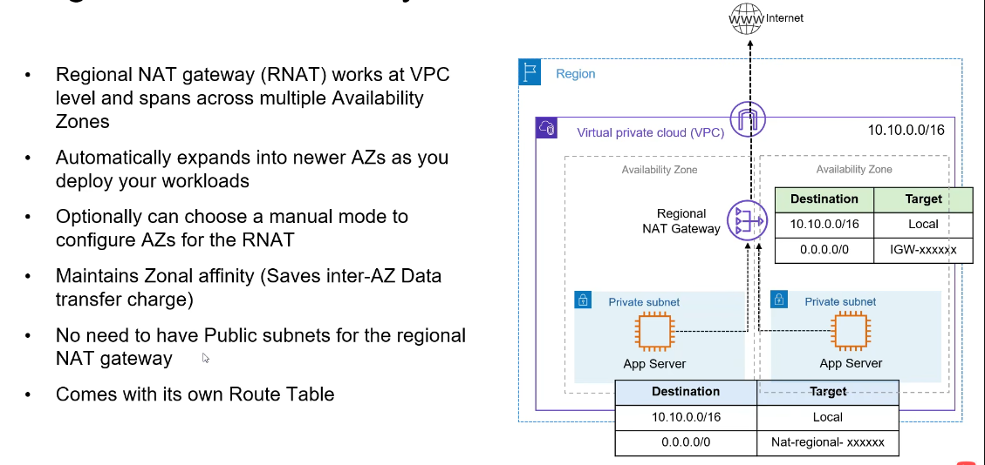

Exercise - Regional NAT Gateway:

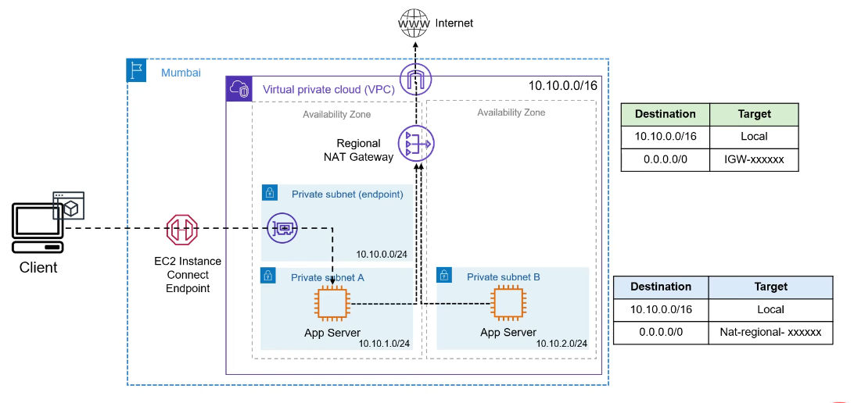

1.Go to VPC:
Name : NAT -Test-VPC
IPV4 CIDR : 10.10.0.0/16 ( No IPV6 CIDR block)
Click ->Create VPC
=================================================
2. Go to Internet Gateway :
Name tag : Test -ig
Click -> Create
Action -Attach to VPC
Select VPC -> NAT -Test-VPC
============================================================
3. Create Subnet :
VPC : NAT -Test-VPC
Subnet name : EC2- endpoint-Private
AZ : ap-south-1a
IPV4 Subnet CIDR block : 10.10.0.0/24
Click Add Subnet
Subnet 2 of 2
Subnet name : app-private-1
AZ : ap-south-1a
IPV4 Subnet CIDR block : 10.10.1.0/24
Click Add Subnet
Subnet 3 of 3
Subnet name : app-private-2
AZ : ap-south-1b
IPV4 Subnet CIDR block : 10.10.2.0/24
Click -> Create Subnet
============================================================
Route Table :
Click ->Create Route Table
Name: app-private
VPC: NAT -Test-VPC
Click -> Create Route table
Click -> Subnet associations ->Click Edit Subnet association Select only app-private-1 and app-private-2 --> Click save Associations
=============================================================
Endpoints :
Under VPC -> Cilck Endpoints ( PrivateLink and Lattice -left side)
Click Create endpoint
Name:ec2-instance-connect
Type: select EC2 Instance Connect endpoint
Network Setting : VPC ->Select NAT -Test-VPC
Security group: Go to EC2->Security Group-> Create security group
Name: ec2-instance-connect-endpoint-sg
Description: Allow outbound
VPC ->Select NAT -Test-VPC
Reaming leaves it as it is
Click->Create security group

Go to Endpoint (VPC->Endpoints->Create endpoint)
Security group: select ec2-instance-connect-endpoint-sg
Subnet: select EC2- endpoint-Private
Click -> create endpoint

Go to EC2
Instances : Lauch instance
Name: app-1
Keep remaining as it is free
Key pari : select your key pair
Network Settings : Click -> Edit
VPC ->Select NAT -Test-VPC
Subnet: app-private-1
Firewall (Security group)
Select Create security group-> name: app-sg ->
Inbound : Type SSH ; Source type : Custom; Source : ec2-instance-connect-endpoint-sg
Click -> launch instance

2. Instances : Lauch instance
Name: app-2
Keep remaining as it is free
Key pari : select your key pair
Network Settings : Click -> Edit
VPC ->Select NAT -Test-VPC
Subnet: app-private-2
Firewall (Security group)
Select existing security group : select “ app-sg “
Click -> launch instance
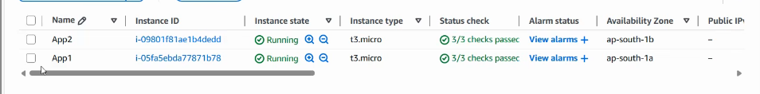

Select App1 and click Connect
EC2 Instance Connect -> Select Connect using a Private IP and remaining automatically select and finally click Connect
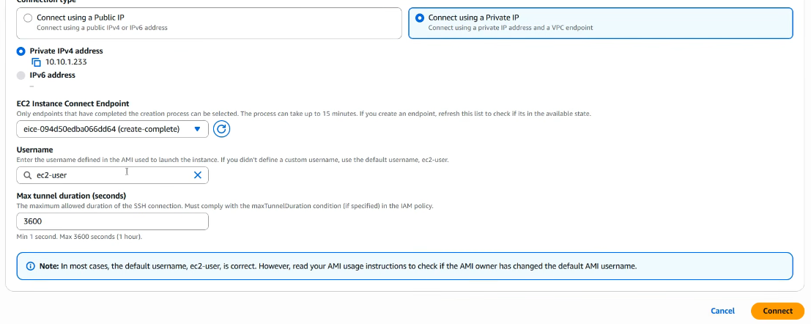

After connect
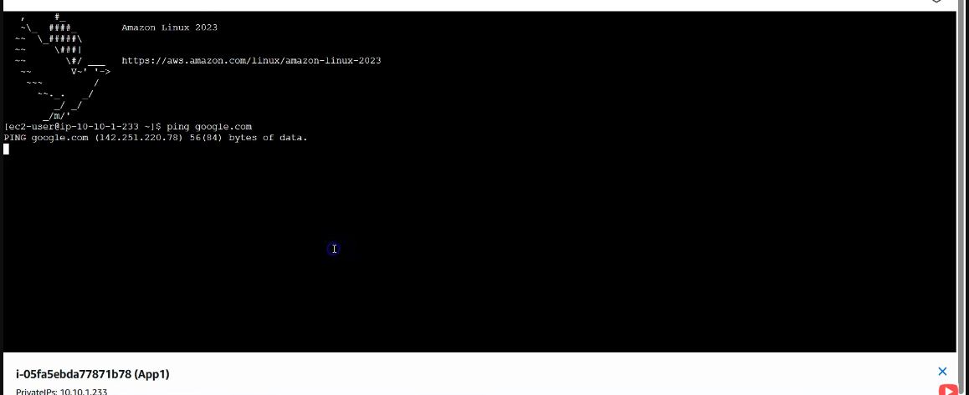

Ping will not work since we don’t have outbound Rules

Go to NAT Gateway : (VPC->NAT gateway )
Name : Test RNAT
Availability : select Regional -New
VPC ->Select NAT -Test-VPC
Connectivity type : Select Public
Method of Elastic IP (EIP) allocation : Automatic
Cilck -> Create Nat gateway
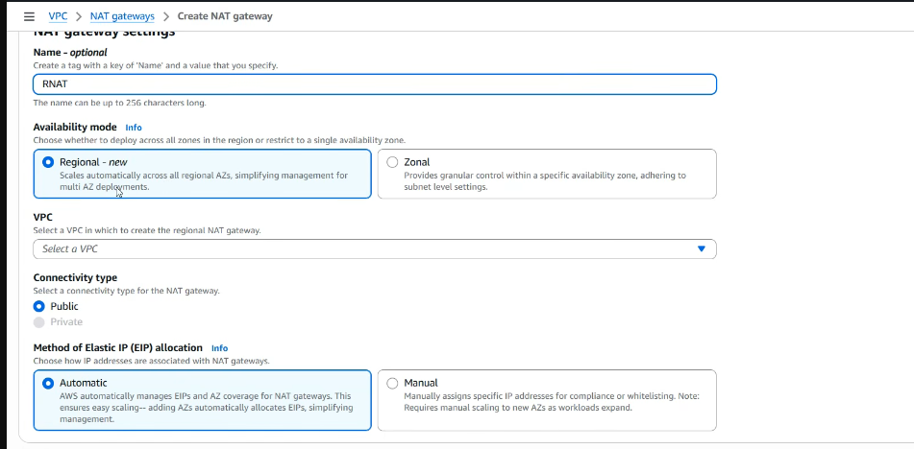

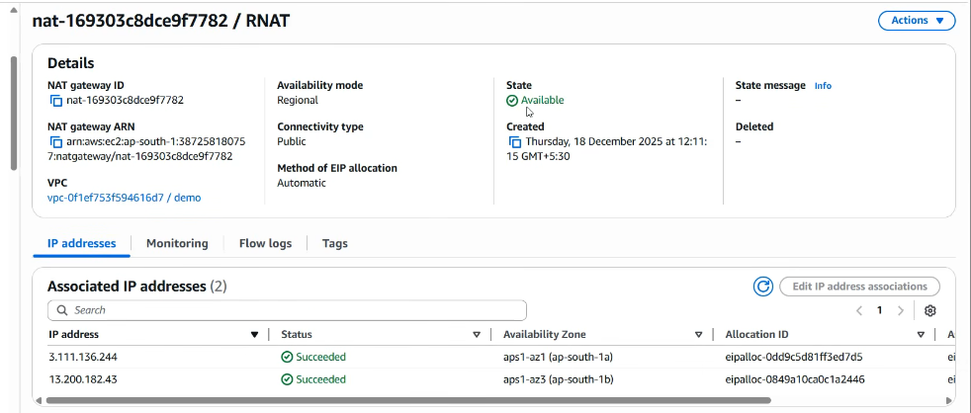

Update the Route table for App-1 and App-2 for internet Access using NAT gateway

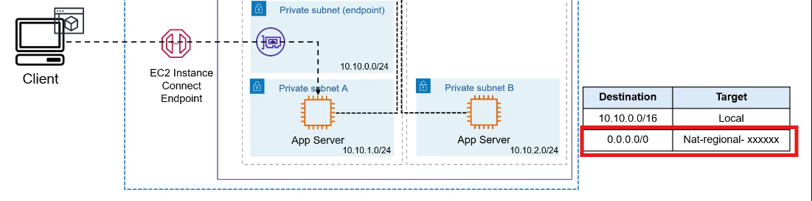

Select App-private (Route tables):
Click route ->edit routes
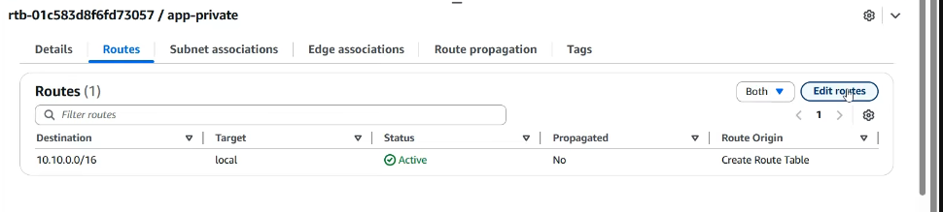
Add 0.0.0.0 -> NAT Gateway
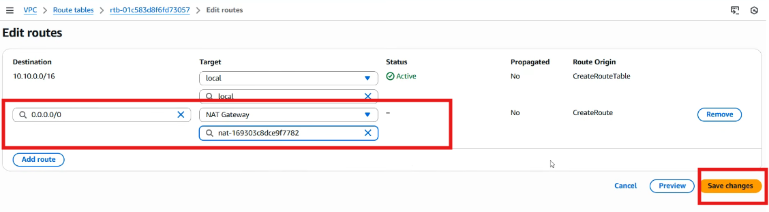

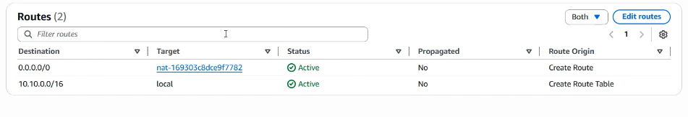
Go to EC2 app and check is it ping is working for google.com
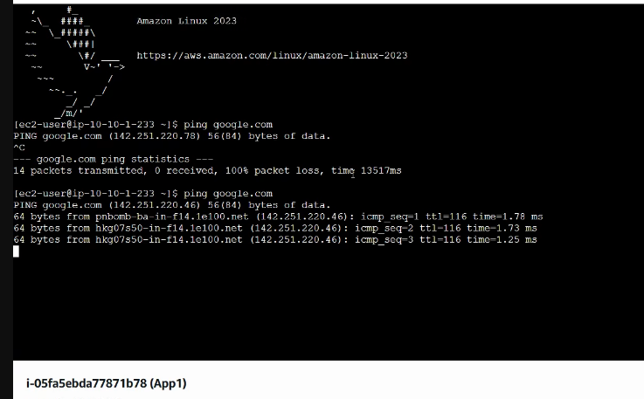

Try to connect the app-2 ec2 instance and test ping response of App2 ec2 instance.
Once test is successfully , then go DELETE the EC2 Instances and NAT GATWAY .

